Jaypee Institute of Information Technology


Minor Project-1
Synopsis

CodeRoom: Code Evaluation System

Mentor: | Submitted By:
Mr. Amitesh Pandey  Panel Members  Dr. Tanvi Gautam Mr. Megh Singhal | Yash Gupta 23103007  Hansi Gupta 23803019  Kanishk Richhariya 23103125

2025-2026
Fifth Semester

Table of Contents
- Introduction… 3
- Problem Statement… 3
- Objectives… 3
- Flow Chart… 4
- Platform Layout… 5
- Implementation… 6
- Expected Results… 6
- Future Scope… 7
- References… 7

Introduction

This project focuses on developing a Code Evaluation Platform that simplifies and automates the process of coding assignment creation, submission, and evaluation.The platform allows
professors to create assignments with detailed problem descriptions, sample, hidden, and random test cases, as well as set due dates for submissions. Students can write, run, and submit code directly from the integrated online editor without requiring local setup.The system is designed to handle real-time compilation and evaluation of student code in a secure, isolated environment. Professors can view all submissions, download reports, and track student performance.

Problem Statement
Managing coding assignments manually is time-consuming and prone to errors. Professors must manually check code, test against various cases, and record marks, which delays feedback for students.Existing platforms are often either too complex or lack flexibility (for example, limited test case management or no real-time feedback).

Objectives

  - To develop a web-based platform where professors can create and assign coding problems to students.
  - To provide an integrated code editor and compiler for students to write and test their solutions online.
  - To implement a judge system that automatically compiles and evaluates submissions against sample, hidden, and random test cases.
  - To allow professors to view submissions, grades, and analytics for better student performance tracking.

- WorkFlow

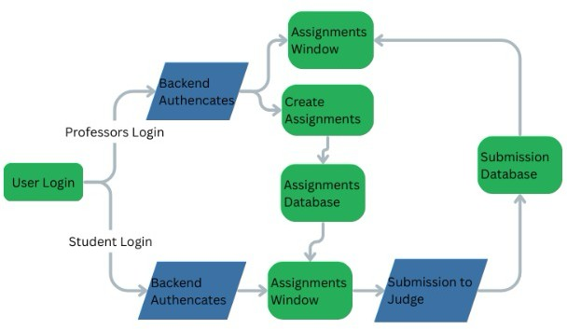

Fig.1: Flow chart

Platform Layout

  - Professor Dashboard: A clean and intuitive interface for managing assignments, adding test cases and downloading result reports.
  - Student Dashboard: A simple and distraction-free workspace with an integrated code editor, compile/run button, and submission history panel.
  - Judge/Execution Layer:Judge0 API for secure execution of code submissions with time and memory limits.
  - The system will handle multiple concurrent submissions efficiently during lab sessions or deadlines.

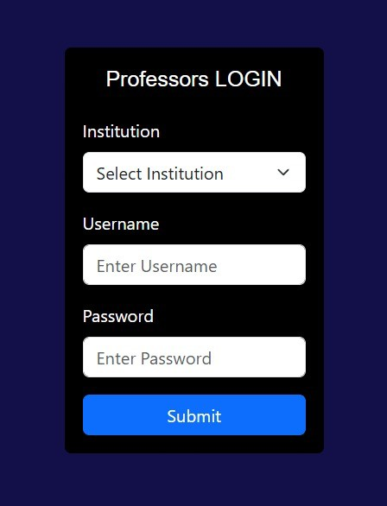
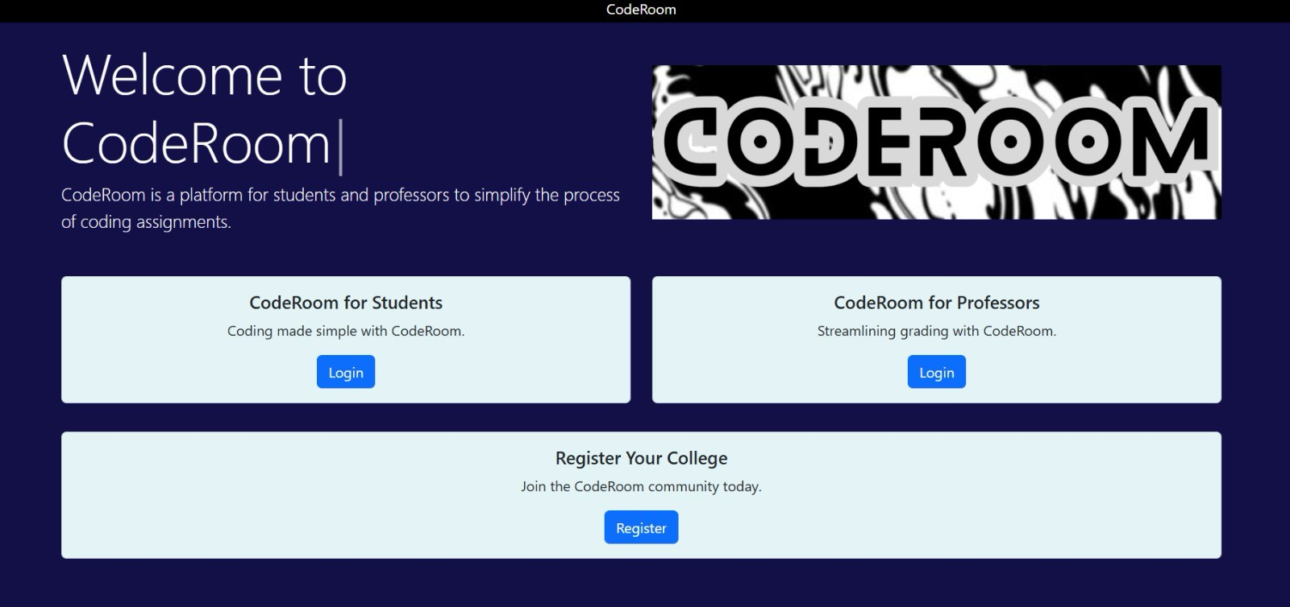

Implementation

Frontend: Built using React.js + TailwindCSS for a responsive UI.

Backend: Developed using Node.js + Express.js, exposing REST APIs for authentication, assignments, and submissions.

Database:MongoDB to store problem descriptions, test cases, and user data.

JudgeJudge0 API used for secure code execution.

Authentication: JWT for secure login.

- Expected Result

  - Professors will be able to create, assign, and manage coding problems from a single dashboard, reducing administrative work.
  - Students will be able to instantly test and submit solutions, receiving detailed feedback to help them learn and iterate quickly.
  - The platform will generate performance analytics, enabling professors to identify weak areas and guide students accordingly.
  - The system will handle multiple concurrent submissions efficiently during lab sessions or deadlines.

Future Scope

  - AI-Powered Hints & Explanations: Provide step-by-step logical guidance and complexity analysis of student solutions.
  - Language Expansion: Support additional programming languages such as Java, JavaScript, Go, and Rust.
  - Plagiarism Detection: Implement ML-based similarity detection to catch copied solutions and maintain academic integrity.
  - Gamification: Add leaderboards, badges, and timed challenges to motivate students and make coding more competitive and fun.
  - Notification System: Send automated reminders for approaching deadlines and publish results via Email/SMS/Push notifications.

References

  - Judge0 API Documentation: https://judge0.com/
  - Node.js & Express.js Documentation: https://expressjs.com/
  - MongoDB Documentation: https://www.mongodb.com/docs/
  - Google OAuth 2.0 Guide: https://developers.google.com/identity/
  - Docker Documentation: https://docs.docker.com/

